Letter of invitation to tender
Tbilisi, 23 December 2014

Our ref.: Publication reference: EuropeAid136622/IH/SUP/GE
Procurement/Contract Reference: EUMM-14-3459
Dear Sirs,

SUBJECT: Invitation to Local Open Tender procedure for supply contract for supply and delivery of visibility items with design for EUMM Georgia.
This is an invitation to tender for the above mentioned supply contract. Please find enclosed the following documents, which constitute the tender dossier:
- Instructions to tenderers
- Draft contract and special conditions, including annexes
- Draft contract
- Special conditions
- Annex i: general conditions
- Annex ii +iii: technical specifications + technical offer (to be tailored to the specific project)
- Annex iv: budget breakdown (model financial offer)
- Annex v: forms
- Further information
- Administrative compliance grid
- Evaluation grid
- Tender form for a supply contract
For full information about procurement procedures please consult the Practical Guide and its annexes, which can be downloaded from the following web page: http://ec.europa.eu/europeaid/prag/document.do?locale=en
We look forward to receiving your tender at EUMM headquarters (49 Krtsanisi Street, 0114 Tbilisi, Georgia) before the deadline 15:00 hrs (Georgian Standard Time) on 26 January 2015, by registered letter with acknowledgement of receipt or hand-delivered against receipt signed by its representative.
Yours sincerely,

EUMM Procurement Section

TENDER DOSSIER
EUMM-14-3459

PART A

INSTRUCTIONS TO TENDERERS

A. INSTRUCTIONS TO TENDERERS
Procurement ref: EUMM-14-3459
By submitting a tender, tenderers fully and unreservedly accept the special and general conditions governing the contract as the sole basis of this tendering procedure, whatever their own conditions of sale may be, which they hereby waive. Tenderers are expected to examine carefully and comply with all instructions, forms, contract provisions and specifications contained in this tender dossier. Failure to submit a tender containing all the required information and documentation within the deadline specified will lead to the rejection of the tender. No account can be taken of any remarks in the tender relating to the tender dossier; remarks may result in the immediate rejection of the tender without further evaluation.
These Instructions set out the rules for the submission, selection and implementation of contracts financed under this call for tenders, in conformity with the Practical Guide (available on the Internet at:
http://ec.europa.eu/europeaid/work/procedures/index_en.htm).
- Supplies to be provided

1.1 The subject of the Contract is the supply and delivery of the following visibility items with design specified in one lot:
Item NUMBER | DESCRIPTION | Estimated Quantity
1 | Ball-point pen | 1000
2 | Coloured metal ball-point pen | 600
3 | Notepads (block note A5) | 1000
4 | Notepads (block note A6) | 1000
5 | Crayon boxes | 500
6 | Mugs | 500
7 | Balloons | 1000
8 | Safety bracelets | 500
9 | Paper gift bag | 300
10 | Cotton bags | 300
11 | Volley balls | 200
12 | T-Shirts | 600
13 | Paper Folders | 300
14 | Sport Drink Bottles | 500
15 | Flash Drive, Memory sticks | 300
16 | Journal with pen | 150
The place of delivery, inspection and acceptance of goods shall be made at the the EUMM Headquarters Warehouse (49 Krtsanisi Street – 0114 Tbilisi – Georgia) DDP based on INCOTERMS 2010. The implementation period of the Contract is in accordance with point 15 of the Contract notice.
The time limit for delivery shall be 45 (forty-five) calendar days (15 calendar days for design and 30 calendar days for supply and delivery) from the date of signature of a Contract by all parties and the Incoterm applicable shall be DDP. Acceptance shall take place within 30 calendar days of receipt of goods.

1.2 The supplies must comply fully with the technical specifications set out in the tender dossier (technical annex) and conform in all respects with the drawings, quantities, models, samples, measurements and other instructions.

1.3 Tenderers are not authorised to tender for a variant solution in addition to the present tender.
- Timetable
 | DATE | TIME*
Clarification meeting | 29 December 2014 | 14:00 hrs (Georgian standard time)
Deadline for requesting clarifications from the Contracting Authority | 6 January 2015 | -
Last date on which clarifications are issued by the Contracting Authority | 16 January 2015 | -
Deadline for submission of tenders | 26 January 2015 | 15:00 hrs (Georgian standard time)
Tender opening session | 26 January 2015 | 15:30 hrs (Georgian standard time)
Notification of award to the successful tenderer | January /February 2015 | -
Signature of the contract | February 2015 | -
* All times are in the time zone of the country of the Contracting Authority Provisional date
- Participation
3.1 Participation in this tender procedure is open to all natural persons participating either individually or in a grouping (consortium) of tenderers. No nationality restrictions apply to the any of the tenderers. Subcontracting is not allowed.

3.2 These rules apply to:
- tenderers
- members of a consortium

3.3 Natural persons, companies or undertakings falling into one of the situations set out in section 2.3.3 of the Practical Guide are excluded from participation in and the award of contracts. Tenderers must provide declarations that they are not in any of these exclusion situations. The declarations must cover all the members of a joint venture/consortium. Tenderers who make false declarations may also incur financial penalties and exclusion in accordance with section 2.3.4 of the Practical Guide.

3.4 To be eligible to take part in this tender procedure, tenderers must prove to the satisfaction of the Contracting Authority that they comply with the necessary legal, technical and financial requirements and have the means to carry out the contract effectively, particularly:
- Origin

4.1 No restrictions whatsoever shall apply to the origins of the supplies.
- Type of contract

Unit-price.
- Currency

EUR.
- Lots
This tender procedure is not divided into lots.
- Period of validity

8.1 Tenderers will be bound by their tenders for a period of 90 days from the deadline for the submission of tenders.

8.2 In exceptional cases and prior to the expiry of the original tender validity period, the Contracting Authority may ask tenderers in writing to extend this period by 40 days. Such requests and the responses to them must be made in writing. Tenderers that agree to do so will not be permitted to modify their tenders and they are bound to extend the validity of their tender guarantees for the revised period of validity of the tender. If they refuse, without forfeiture of their tender guarantees, their participation in the tender procedure will be terminated.
8.3 The successful tenderer will be bound by its tender for a further period of 60 days. The further period is added to the validity period of the tender irrespective of the date of notification.
- Language of tenders

9.1 The tenders, all correspondence and documents related to the tender exchanged by the tenderer and the Contracting Authority must be written in the language of the procedure, which is English.

If the supporting documents are not written in one of the official languages of the European Union, a translation into the language of the call for tender must be attached. Where the documents are in an official language of the European Union other than English, it is strongly recommended to provide a translation into English, to facilitate evaluation of the documents.
- Submission of tenders

10.1 The Contracting Authority must receive the tenders before the deadline specified in 10.3. They must include all the documents specified in point 11 of these Instructions and be sent to the following address:
European Union Monitoring Mission in Georgia (EUMM)
Procurement Section
49 Krtsanisi Street
0114 Tbilisi
Georgia
If the tenders are hand delivered they should be delivered to the following address:
European Union Monitoring Mission in Georgia (EUMM)
Procurement Section
49 Krtsanisi Street
0114 Tbilisi
Georgia

Tenders must comply with the following conditions:

10.2 All tenders must be submitted in 1 (one) original, marked ‘original’, and 3 (three) copies signed in the same way as the original and marked ‘copy’.

10.3 All tenders must be received at EUMM headquarters (49 Krtsanisi Street, 0114 Tbilisi, Georgia) before the deadline 15:00 hrs (Georgian Standard Time) on 26 January 2015, by registered letter with acknowledgement of receipt or hand-delivered against receipt signed by its representative.

10.4 All tenders, including annexes and all supporting documents, must be submitted in a sealed envelope bearing only:
a) the above address;
b) the reference code of this tender procedure, (i.e. procurement reference: EUMM-14-3459);
c) where applicable, the number of the lot(s) tendered for;
d) the words ‘Not to be opened before the tender opening session’ in the language of the tender dossier and "არ უნდა გაიხსნას ტენდერის ჩატარების მომენტამდე";
e) the name of the tenderer.

The technical and financial offers must be placed together in a sealed envelope. The envelope should then be placed in another single sealed envelope/package, unless their volume requires a separate submission for each lot.
- Content of tenders

All tenders submitted must comply with the requirements in the tender dossier and comprise:

Part 1: Technical offer:
Part 1: Technical offer:  A detailed description of the supplies tendered in conformity with the technical specifications, including any documentation required; | 1 | The technical offer should be presented as per template (annex II+III, the Contractor’s technical offer) completed when and if necessary by separate sheets for details.  Samples for all items should be provided in a separate box and provided together with the offer before the deadline.
Part 2: Financial offer:  A financial offer calculated on a basis of DDP (to EUMM HQ warehouse) for the supplies tendered. | 2.1 | This financial offer should be presented as per template (annex IV, budget breakdown), and if necessary completed by separate sheets for the details.
 | 2.2 | An electronic version of the financial offer (Excel file or equivalent).
Part 3.1: Documentation:  To be supplied following templates provided in this tender dossier (also available on http://ec.europa.eu/europeaid/prag/ document.do) | 3.1.1 | The “Tender Form for a Supply Contract”, duly completed, signed, dated and stamped.
 | 3.1.2 | Tenderer’s declaration, point 7 of the tender form for a supply contract, duly signed, dated and stamped.
 | 3.1.3 | The details of the bank account into which payments should be made (financial identification form) (Tenderers that have already signed another Contract with the EUMM, may provide their financial identification form number instead of the financial identification form, or a copy of the financial identification form provided on that occasion, if no change has occurred in the meantime.)
 |  | The legal entity file and the supporting documents (Tenderers that have already signed another Contract with the EUMM, may provide their legal entity number instead of the legal entity sheet and supporting documents, or a copy of the legal entity sheet provided on that occasion, if no change in legal status has occurred in the meantime.
Part 3.2: Documentation to be supplied in free format. | 3.2.1 | Registration certificate / An extract from entrepreneurs register.
Part 3.2: Documentation to be supplied in free format. | 3.2.2 | Duly authorized signature: an official document (statutes, power of attorney, notary statement, etc.) proving that the person who signs on behalf of the company is duly authorized to do so.

Remarks:
Tenderers are requested to follow this order of presentation.
Annex* refers to templates attached to the tender dossier. These templates are also available on: http://ec.europa.eu/europeaid/work/procedures/index_en.htm
- Taxes and other charges

The European Union and Georgia have agreed on the status of the European Union Monitoring Mission in Georgia (SOMA - 3 November 2008) that: “EUMM Georgia, shall be exempt from all national, regional and communal dues, taxes and charges of a similar nature In respect of purchased and imported goods, services provided and Facilities used by it for the purposes of the Mission”.
- Additional information before the deadline for submission of tenders
The tender dossier should be so clear that tenderers do not need to request additional information during the procedure. If the Contracting Authority, on its own initiative or in response to a request from a prospective tenderer, provides additional information on the tender dossier, it must send such information in writing to all other prospective tenderers at the same time.
Tenderers may submit questions to the Contracting Authority in writing to the following e-mail address tenders@eumm.eu before or on 6 January 2015.
The Contracting Authority has no obligation to provide clarifications after this date.
Any clarification of the tender dossier will be provided before or on 16 January 2015.
Any prospective tenderers seeking to arrange individual meetings with either the Contracting Authority and/or the European Commission during the tender period may be excluded from the tender procedure.
- Clarification / Information meeting
A clarification meeting will be held on 29 December 2014 at 14:00 hrs (Georgian Standard Time) at EUMM HQ, 49 Krtsanisi Street, 0114 Tbilisi, Georgia.
- Alteration or withdrawal of tenders

15.1 Tenderers may alter or withdraw their tenders by written notification prior to the deadline for submission of tenders referred to in Article 10.1. No tender may be altered after this deadline. Withdrawals must be unconditional and will end all participation in the tender procedure.

15.2 Any such notification of alteration or withdrawal must be prepared and submitted in accordance with Article 10. The outer envelope must be marked ‘Alteration’ or ‘Withdrawal’ as appropriate.

15.3 No tender may be withdrawn in the interval between the deadline for submission of tenders referred to in Article 10.1 and the expiry of the tender validity period. Withdrawal of a tender during this interval may result in forfeiture of the tender guarantee.
- Costs of preparing tenders
No costs incurred by the tenderer in preparing and submitting the tender are reimbursable. All such costs will be borne by the tenderer.
- Ownership of tenders
The Contracting Authority retains ownership of all tenders received under this tender procedure. Consequently, tenderers have no right to have their tenders returned to them.
- Joint venture or consortium

18.1 If a tenderer is a joint venture or consortium of two or more persons, the tender must be a single one with the object of securing a single contract, each person must sign the tender and will be jointly and severally liable for the tender and any contract. Those persons must designate one of their members to act as leader with authority to bind the joint venture or consortium. The composition of the joint venture or consortium must not be altered without the prior written consent of the Contracting Authority.

18.2 The tender may be signed by the representative of the joint venture or consortium only if it has been expressly so authorised in writing by the members of the joint venture or consortium, and the authorising contract, notarial act or deed must be submitted to the Contracting Authority in accordance with point 11 of these Instructions to Tenderers. All signatures to the authorising instrument must be certified in accordance with the national laws and regulations of each party comprising the joint venture or consortium together with the powers of attorney establishing, in writing, that the signatories to the tender are empowered to enter into commitments on behalf of the members of the joint venture or consortium. Each member of such joint venture or consortium must provide the proof required under Article 3.5 as if it, itself, were the tenderer.
- Opening of tenders

19.1 The opening and examination of tenders is for the purpose of checking whether the tenders are complete, whether the requisite tender guarantees have been furnished, whether the required documents have been properly included and whether the tenders are generally in order.

19.2 The tenders will be opened in the session on 15:30 hrs (Georgian Standard Time) on 26 January 2015 at EUMM HQ by the committee appointed for the purpose. The committee will draw up minutes of the meeting, which will be available on request.

19.3 At the tender opening, the tenderers’ names, the tender prices, any discount offered, written notifications of alteration and withdrawal and such other information as the Contracting Authority may consider appropriate may be announced.

19.4 After the opening of the tenders, no information relating to the examination, clarification, evaluation and comparison of tenders, or recommendations concerning the award of the contract can be disclosed until after the contract has been awarded.

19.5 Any attempt by tenderers to influence the evaluation committee in the process of examination, clarification, evaluation and comparison of tenders, to obtain information on how the procedure is progressing or to influence the Contracting Authority in its decision concerning the award of the contract will result in the immediate rejection of their tenders.

19.6 All tenders received after the deadline for submission specified in the contract notice or these instructions will be kept by the Contracting Authority. The associated guarantees will be returned to the tenderers. No liability can be accepted for late delivery of tenders. Late tenders will be rejected and will not be evaluated.
- Evaluation of tenders

20.1 Examination of the administrative conformity of tenders

The aim at this stage is to check that tenders comply with the essential requirements of the tender dossier. A tender is deemed to comply if it satisfies all the conditions, procedures and specifications in the tender dossier without substantially departing from or attaching restrictions to them.

Substantial departures or restrictions are those which affect the scope, quality or execution of the contract, differ widely from the terms of the tender dossier, limit the rights of the Contracting Authority or the tenderer’s obligations under the contract or distort competition for tenderers whose tenders do comply. Decisions to the effect that a tender is not administratively compliant must be duly justified in the evaluation minutes.

If a tender does not comply with the tender dossier, it will be rejected immediately and may not subsequently be made to comply by correcting it or withdrawing the departure or restriction.

20.2 Technical evaluation

After analysing the tenders deemed to comply in administrative terms, the evaluation committee will rule on the technical admissibility of each tender, classifying it as technically compliant or non-compliant.

The minimum qualifications required (see selection criteria in Contract notice point 16) are to be evaluated at the start of this stage.

Where contracts include after-sales service and/or training, the technical quality of such services will also be evaluated by using yes/no criteria as specified in the tender dossier.

20.3 In the interests of transparency and equal treatment and to facilitate the examination and evaluation of tenders, the evaluation committee may ask each tenderer individually for clarification of its tender including breakdowns of prices, within a reasonable time limit to be fixed by the evaluation committee. The request for clarification and the response must be in writing, but no change in the price or substance of the tender may be sought, offered or permitted except as required to confirm the correction of arithmetical errors discovered during the evaluation of tenders pursuant to Article 20.4. Any such request for clarification must not distort competition. Decisions to the effect that a tender is not technically compliant must be duly justified in the evaluation minutes.

20.4 Financial evaluation
a) Tenders found to be technically compliant will be checked for any arithmetical errors in computation and summation. Errors will be corrected by the evaluation committee as follows:

- where there is a discrepancy between amounts in figures and in words, the amount in words will be the amount taken into account;

- except for lump-sum contracts, where there is a discrepancy between a unit price and the total amount derived from the multiplication of the unit price and the quantity, the unit price as quoted will be the price taken into account.
b) Amounts corrected in this way will be binding on the tenderer. If the tenderer does not accept them, its tender will be rejected.

20.5 Variant solutions
Variant solutions will not be taken into consideration.

20.6 Award criteria

The sole award criterion will be the price. The contract will be awarded to the lowest compliant tender.
- Signature of the contract and performance guarantee
21.1 The successful tenderer will be informed in writing that its tender has been accepted (notification of award). Before the Contracting Authority signs the contract with the successful tenderer, the successful tenderer may be requested to provide the documentary proof or statements required under the law of the country in which the company (or each of the companies in case of a consortium) is established, to show that it is not in any of the exclusion situations listed in section 2.3.3 of the Practical Guide. This evidence or these documents or statements must carry a date not earlier than one year before the date of submission of the tender. In addition, a statement must be provided that the situations described in these documents have not changed since then.

21.2 The successful tenderer may be requested also provide evidence of financial and economic standing and technical and professional capacity according to the selection criteria for this call for tenders specified in the contract notice, point 16. The documentary proofs required are listed in section 2.4.11 of the Practical Guide.

21.3 If the successful tenderer fails to provide the documentary proof or statement or the evidence of financial and economic standing and technical and professional capacity within 15 calendar days following the notification of award or if the successful tenderer is found to have provided false information, the award will be considered null and void. In such a case, the Contracting Authority may award the tender to the next lowest tenderer or cancel the tender procedure.

21.4 The Contracting Authority reserves the right to vary quantities specified in the tender by +/- 100 % at the time of contracting and during the validity of the contract. The total value of the supplies may not, as a result of the variation rise or fall by more than 25 % of the original financial offer in the tender. The unit prices quoted in the tender shall be used.

21.5 Within 30 days of receipt of the contract signed by the Contracting Authority, the selected tenderer must sign and date the contract and return it, with the performance guarantee (if applicable), to the Contracting Authority. On signing the contract, the successful tenderer will become the Contractor and the contract will enter into force.

21.6 If it fails to sign and return the contract and any financial guarantee required within 30 days after receipt of notification, the Contracting Authority may consider the acceptance of the tender to be cancelled without prejudice to the Contracting Authority’s right to seize the guarantee, claim compensation or pursue any other remedy in respect of such failure, and the successful tenderer will have no claim whatsoever on the Contracting Authority.

21.7 The performance guarantee is not requested.
- Tender guarantee

No tender guarantee is required.
- Ethics clauses

23.1 Any attempt by a candidate or tenderer to obtain confidential information, enter into unlawful agreements with competitors or influence the committee or the Contracting Authority during the process of examining, clarifying, evaluating and comparing tenders will lead to the rejection of their candidacy or tender and may result in administrative penalties.

23.2 Without the Contracting Authority’s prior written authorisation, a Contractor and its staff or any other company with which the Contractor is associated or linked may not, even on an ancillary or subcontracting basis, supply other services, carry out works or supply equipment for the project. This prohibition also applies to any other projects that could, owing to the nature of the contract, give rise to a conflict of interest on the part of the Contractor.

23.3. When submitting a tender, tenderers must declare that they are not affected by a conflict of interest and have no equivalent relation in that respect with other tenderers or parties involved in the project. Should such a situation arise during execution of the contract, the Contractor must immediately inform the Contracting Authority.

23.4 Contractors must at all times act impartially and as faithful advisers in accordance with the code of conduct of their profession. They will refrain from making public statements about the project or services without the Contracting Authority’s prior approval. They may not commit the Contracting Authority in any way without its prior written consent.

23.5 For the duration of the contracts Contractors and their staff must respect human rights and undertake not to offend the political, cultural and religious mores of the beneficiary state. In particular and in accordance with the legal basic act concerned, tenderers that have been awarded contracts must abide by core labour standards as defined in the relevant International Labour Organisation conventions (such as the Conventions on freedom of association and collective bargaining; Abolition of forced and compulsory labour; Elimination of forced and compulsory labour; Abolition of child labour).

23.6 Contractors may accept no payment connected with the contracts other than that provided for therein. Contractors and their staff must not exercise any activity nor receive any advantage inconsistent with their obligations to the Contracting Authority.

23.7 Contractors and their staff are obliged to maintain professional secrecy for the entire duration of contracts and after their completion. All reports and documents drawn up or received by Contractors will be confidential.

23.8 The contract governs the Contracting Parties’ use of all reports and documents drawn up, received or presented by them during the implementation of the contract.

23.9 Contractors must refrain from any relationship likely to compromise their independence or that of their staff. If the Contractor ceases to be independent, the Contracting Authority may, regardless of injury, terminate the contract without further notice and without the Contractor having any claim to compensation.

23.10 The Commission reserves the right to suspend or cancel project financing if corrupt practices of any kind are discovered at any stage of the award process and if the Contracting Authority fails to take all appropriate measures to remedy the situation. For the purposes of this provision, ‘corrupt practices’ are the offer of a bribe, gift, gratuity or commission to any person as an inducement or reward for performing or refraining from any act relating to the award of a contract or implementation of a contract already concluded with the Contracting Authority.

23.11 All tenders will be rejected or contracts terminated if it emerges that the award or implementation of a contract has given rise to unusual commercial expenses. Such unusual commercial expenses are commissions not mentioned in the main contract or not stemming from a properly concluded contract referring to the main contract, commissions not paid in return for any actual and legitimate service, commissions remitted to a tax haven, commissions paid to a recipient who is not clearly identified or commissions paid to a company which has any appearance of being a front company.

23.12 The Contractor undertakes to supply the Commission on request with all supporting documents relating to the conditions of the contract’s execution. The Commission may carry out whatever documentary or on-the-spot checks it deems necessary to find evidence in cases of suspected unusual commercial expenses.

23.13 Contractors found to have paid unusual commercial expenses on projects funded by the EU are liable, depending on the seriousness of the facts observed, to have their contracts terminated or to be permanently excluded from receiving EU funds.

23.14 The Contracting Authority reserves the right to suspend or cancel the procedure, if the award procedure proves to have been subject to substantial errors, irregularities or fraud. Where such substantial errors, irregularities or fraud are discovered after the award of the Contract, the Contracting Authority may refrain from concluding the Contract.
- Cancellation of the tender procedure
If a tender procedure is cancelled, tenderers will be notified by the Contracting Authority. If the tender procedure is cancelled before the tender opening session the sealed envelopes will be returned, unopened, to the tenderers.
Cancellation may occur, for example, if:
- the tender procedure has been unsuccessful, namely where no qualitatively or financially worthwhile tender has been received or there has been no valid response at all;
- the economic or technical parameters of the project have changed fundamentally;
- exceptional circumstances or force majeure render normal implementation of the project impossible;
- all technically compliant tenders exceed the financial resources available;
- there have been irregularities in the procedure, in particular where these have prevented fair competition;
- the award is not in compliance with sound financial management, i.e. does not respect the principles of economy, efficiency and effectiveness (e.g. the price proposed by the tenderer to whom the contract is to be awarded is objectively disproportionate with regard to the price of the market.
In no event will the Contracting Authority be liable for any damages whatsoever including, without limitation, damages for loss of profits, in any way connected with the cancellation of a tender procedure even if the Contracting Authority has been advised of the possibility of damages. The publication of a contract notice does not commit the Contracting Authority to implement the programme or project announced.
- Appeals
Tenderers believing that they have been harmed by an error or irregularity during the award process may file a complaint. See section 2.4.15 of the Practical Guide.
***

TENDER DOSSIER
EUMM-14-3459

PART B

DRAFT CONTRACT, SPECIFIC CONTRACT TEMPLATE & SPECIAL CONDITIONS

GENERAL CONDITIONS

TECHNICAL SPECIFICATIONS
& TECHNICAL OFFER

BUDGET BREAKDOWN

LEGAL ENTITIES FORM & FINANCIAL IDENTIFICATION FORM

DRAFT CONTRACT
SUPPLY CONTRACT FOR EUROPEAN
UNION EXTERNAL ACTIONS
No EUMM-14-3459

financed from the EU General Budget
European Union Monitoring Mission in Georgia (EUMM)
49 Krtsanisi Street
Tbilisi 0114 – Georgia
(“the Contracting Authority”),
of the one part,
and
<Full official name of Contractor>
[Legal status/title]
[Official registration number]
[Full official address]
[VAT number], (“the Contractor”)
of the other part,

have agreed as follows:

CONTRACT TITLE
Supply and delivery visibility items with design for EUMM Georgia

Identification number: EUMM-14-3459

Article 1 Subject
1.1 The subject of the contract shall be the supply and delivery with design of the following supplies:
Item NUMBER | DESCRIPTION | Estimated Quantity
1 | Ball-point pen | 1000
2 | Coloured metal ball-point pen | 600
3 | Notepads (block note A5) | 1000
4 | Notepads (block note A6) | 1000
5 | Crayon boxes | 500
6 | Mugs | 500
7 | Balloons | 1000
8 | Safety bracelets | 500
9 | Paper gift bag | 300
10 | Cotton bags | 300
11 | Volley balls | 200
12 | T-Shirts | 600
13 | Paper Folders | 300
14 | Sport Drink Bottles | 500
15 | Flash Drive, Memory sticks | 300
16 | Journal with pen | 150
The place of acceptance of the supplies shall be EUMM HQ at 49 Krtsanisi Street, Tbilisi, Georgia, the time limits for delivery shall be maximum 45 (forty-five) calendar days (15 calendar days for design and 30 calendar days for supply and delivery) and the Incoterm applicable shall be DDP. The implementation period of tasks shall run from the signature of the contract from both sides to the date for provisional acceptance.
1.2 The Contractor shall comply strictly with the terms of the Special Conditions and the technical annex.

Article 2 Origin
No restrictions whatsoever shall apply to the origins of the supplies.

Article 3 Price
3.1 The price of the supplies shall be that shown on the financial offer (specimen in Annex IV).
The total maximum contract price shall be GEL/EUR (in words).
3.2 Payments shall be made in accordance with the General and/or Special Conditions (Articles 26 to 28).

Article 4 Order of precedence of contract documents
The contract is made up of the following documents, in order of precedence:
- the contract agreement;
- the Special Conditions
- the General Conditions (Annex I);
- the Technical Specifications (Annex II [including clarifications before the deadline for submission of tenders and minutes from the information meeting/site visit];
- the Technical Offer (Annex III [including clarifications from the tenderer provided during tender evaluation];
- the budget breakdown (Annex IV);
- (specified forms and other relevant documents (Annex V));

The various documents making up the contract shall be deemed to be mutually explanatory; in cases of ambiguity or divergence, they shall prevail in the order in which they appear above.
Done in English in three originals: two originals being for the EUMM - Contracting Authority and one original being for the Contractor.

For the Contractor |  | For the Contracting Authority
Name: |  | Name:
Title: |  | Title:
Signature: |  | Signature:
Date: |  | Date:

SPECIAL CONDITIONS

CONTENTS
These conditions amplify and supplement, if necessary, the General Conditions governing the Contract. Unless the Special Conditions provide otherwise, those General Conditions remain fully applicable. The numbering of the Articles of the Special Conditions is not consecutive but follows the numbering of the Articles of the General Conditions. In exceptional cases, and with the authorisation of the appropriate Commission departments, other clauses may be added to cover specific situations.
Article 2 Language of the Contract
2.1 The language used shall be English.
Article 4 Communications

4.1 Any written communication relating to this Contract between the Contracting Authority and/or the Project Manager, on the one hand, and the Contractor on the other must state the Contract title and identification number, and must be sent by post, fax, e-mail or by hand.

Press and Public Information Officer

49 Krtsanisi St. Tbilisi 0114, Georgia

E-mail:

Alternative (1)
For the Contractor:

Tel:

e-mail:

Article 6 Subcontracting
6.3 Allowed up to 25 % of the value of the contract.
Article 10 Origin

10.1 No restriction on origin of the supplies.
Article 11 Performance guarantee
11.1 No performance guarantee is required.
Article 16 Tax and customs arrangements
16.1 The European Union and Georgia have agreed on the status of the European Union Monitoring Mission in Georgia (SOMA - 3 November 2008) that: “EUMM Georgia, shall be exempt from all national, regional and communal dues, taxes and charges of a similar nature In respect of purchased and imported goods, services provided and Facilities used by it for the purposes of the Mission”.
Article 18 Commencement order
The supply contract shall enter into force from the date of signature from both sides.
Article 19 Period of implementation of the tasks
19.1 The implementation should shall not exceed 45 (forty-five) calendar days (15 calendar days for design and 30 calendar days for supply and delivery) from the commencement date.
The schedule of the design:
1st step: Contractor should submit a desgn within 5 calendar days after signature of the contract.
2nd step: EUMM will have 4 calendar days to approve or send back the request for modification.
3rd step: The contractor should respond with the modified design within 3 calendar days.
Final step: The EUMM should make final approval of the design within 3 calendar days.
Article 26 General principles for payments
26.1 [Payments shall be made in EUR for International companies];
[Payments shall be made in GEL for Georgia-based companies].
Payments will be made in, in accordance with Article 26 of the General Conditions into the bank account notified by the Contractor to the Contracting Authority in accordance with Article 26 of the General Conditions.
The payments will be done after delivery of goods based on the provision acceptance. Actual payment will be made within 30 calendar days after the providing by the Contractor to the Contracting Authority a payment request/invoice in its original format.
Payments shall be authorized and made by the Finance Department of EUMM Georgia, Krtsanisi Residential Area, 49 Krtsanisi Street, 0114 Tbilisi.
Article 29 Delivery
The Contractor shall bear all risks relating to the goods until provisional acceptance at destination. The supplies shall be packaged so as to prevent their damage or deterioration in transit to their destination.
Delivery place is EUMM HQ in Georgia, Krtsanisi Residential Area, 49 Krtsanisi Street, 0114 Tbilisi based on DDP (delivered duty paid) - Incoterms 2010 International Chamber of Commerce.
The delivery shall take place on a working day and during the normal working hours of the Contracting Authority; the “working hour schedule”.
The packaging shall become the property of the recipient subject to respect for the environment.
Article 31 Provisional acceptance
The Certificate of Provisional Acceptance must be issued using the template in
Annex C11.
Article 32 Warranty obligations
The Contractor shall warrant that the supplies are new, unused, of the most recent models and incorporate all recent improvements in design and materials. The Contractor shall further warrant that none of the supplies have any defect arising from design, materials or workmanship.
Article 40 Settlement of disputes
Any disputes arising out of or relating to this Contract which cannot be settled amicably shall be referred to the exclusive jurisdiction of the courts of Brussels, Belgium.
* * *

ANNEX I: GENERAL CONDITIONS
FOR SUPPLY CONTRACTS FINANCED BY THE EUROPEAN UNION OR BY THE EUROPEAN DEVELOPMENT FUND

PLEASE SEE THE PDF FILE THAT IS ATTACHED TO THIS DOCUMENT

THE GENERAL CONDITIONS CAN ALSO BE DOWNLOADED FROM THE EUROPEAID WEBSITE USING THE FOLLOWING LINK:

http://ec.europa.eu/europeaid/prag/annexes.do?group=C

ANNEX II + III : TECHNICAL SPECIFICATIONS + TECHNICAL OFFER

Contract title: Supply and delivery of visibility items with design for EUMM Georgia p 1 /…
Procurement reference: EUMM-14-34359

Column 1-2 should be completed by the Contracting Authority
Column 3-4 should be completed by the tenderer
Column 5 is reserved for the evaluation committee

The tenderers are requested to complete the template on the next pages:
- Column 2 is completed by the Contracting Authority and shows the required specifications and illustrates examples of the requested items (not to be modified by the tenderer);
- Column 3 is to be filled in by the tenderer and must detail what is offered (for example the words “compliant” or “yes” are not sufficient), preferably with pictures of the items and design proposals. Especially on items 10, 12 and 16 creative design proposals are expected. Not only EUMM logo printed in to the item;
- Column 4 allows the tenderer to make comments on its proposed supply and to make eventual references to documentation.

If any documentation is supplied, it should clearly indicate (highlight, mark) the products offered. Bids that do not allow identifying precisely the products offered may be rejected by the evaluation committee. A bidder must provide a description of the supplies offered which must include a sufficient level of detail such as to clearly give the reader a precise and unambiguous understanding of the type of supplies that EUMM can reasonably expect to receive if the contract is awarded to that bidder.
The offer must be clear enough to allow the evaluators to make an easy comparison between the requested specifications and the offered specifications, focusing on describing the quality and design of the items.
All items should be supplied in one lot. Partial offer is not accepted.
The offer must include the cost for design. Logos and photos, or other visual items will be provided by Contracting Authority, but the design of each visibility item must be provided by the Contractor. The Contracting Authority needs to approve all the designs before production.

In addition to completing the template for technical specifications and the tenderers are requested to provide:
- A quality control plan: in a free format to provide narrative plan on quality control.
- The composition of the project core team (including at least a Project Manager, a Graphic Designer and a Quality Controller).

LOT 1 VISIBILITY ITEMS
1.  Item N° | 2.  Specifications Required |  | 3.  Specifications Offered | 4.  Notes, remarks,  ref to documentation | 5.  Evaluation Committee’s notes
1 | Ball-point pen  Ball-point pen with cup pressing (with EUMM website, www.eumm.eu, and with EUMM logo on the body of the pen).  Material: plastic  Colour: EUMM blue  Printing (ink) colour: white  Required printing technique: screen- or pad printing, no graving or sticker etc.  Estimated Quantity: 1,000 | 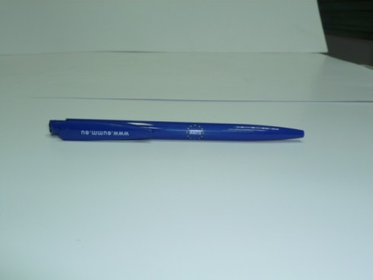
2 | Coloured metal ball-point pen  Coloured metal ballpoint-pen with EUMM logo and website, www.eumm.eu featuring on the blue body of the pen.  Material: metal (and blue plastic).  Colour: blue and silver.  Printing (ink) colour: white.  Required printing technique: screen or pad printing, no craving or sticker etc.  Estimated Quantity: 600 | 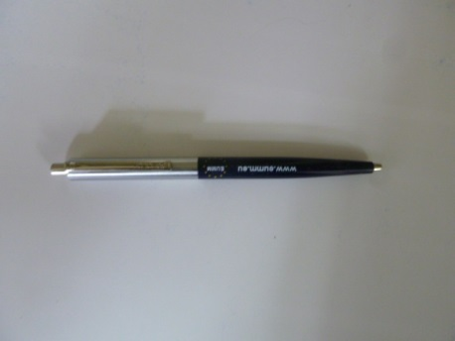
3 | Notepads (block note A5)  Inside 40 thin lined sheets (80 pages) – with no spiral bound.  Size: A5  Inside paper quality: about 80-90g  Cover quality: about 250-300 g  Reversible EN/GEO  Cover colour: full colours  Photos for design to be provided by EUMM.  Estimated Quantity: 1,000 | 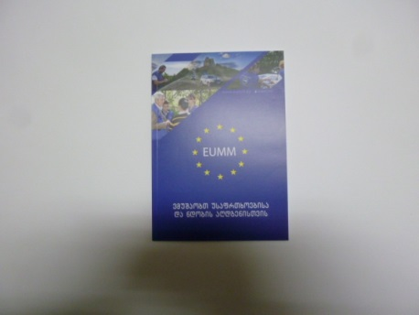  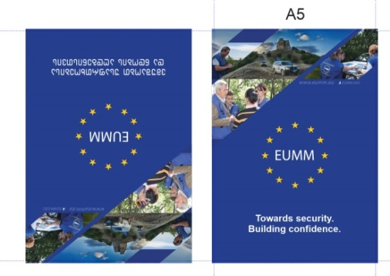
4 | Notepads (block note A6)  Specification: See item 3  Quantity: 1,000
5 | Crayon boxes  Range from 8-15cm crayons in a brown (original carton) colour (see photo) factory box  Including:  - 6-10 different colour crayons (including blue and yellow)  - a sharpener installed in a plastic cap  - a small colouring book, consisting of 7-15 pages (themes of the colouring book: animals, or equivalent theme suitable for children of many ages and both genders)  EUMM logo printed on the top side (facing up), website address www.eumm.eu written on the other side of the box in EUMM blue.  Printing colour (ink): EUMM blue  Estimated Quantity: 500 | 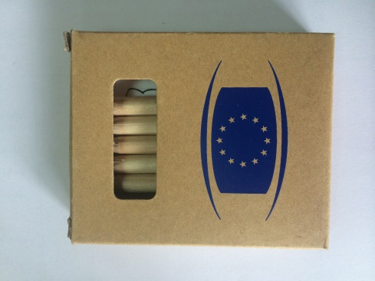  
6 | Mugs  White mugs with EUMM logo and slogan ‘Towards Security. Building Confidence.” Handle and inside white, as well as approximately 1cm rim on bottom and upper edge are left white. Otherwise painted in blue. Logo doesn’t have a frame.  www.eumm.eu written on the opposite side of the mug in white.  Preferable printing method: Transfer/Decal printing (other methods can be suggested with justification to use that by bidder)  Diameter: 8cm + - 1 cm  Each mug should be packed in a carton box.  Estimated Quantity: 500 |   
7 | Balloons  Colour: blue and white  No slogan, only logo printed in the middle of the balloon.  Every 100th balloon should be accompanied by an air- pump (for filling regular air).  Estimated Quantity: 1,000 | 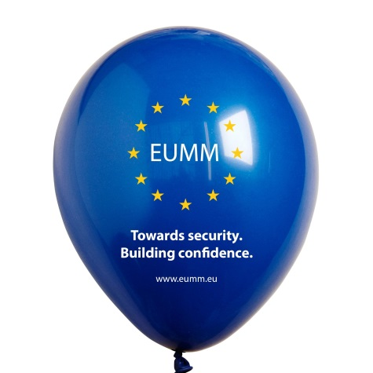
8 | Safety bracelets  Blue reflecting bracelets with EUMM logo and slogan ‘Towards Security. Building Confidence.”  Logo in center and slogans equally on both sides of it.  Size: 250x30mm  Material: Plastic.  Estimated Quantity: 500 | 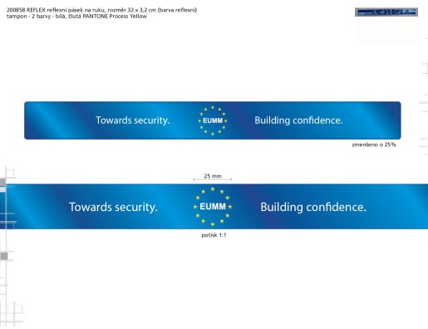
9 | Paper gift bag  Specification: blue paper bag, approximately size of an A4, blue cotton strings/handles, with EUMM logo (in center of the bag) and slogan ‘Towards Security. Building Confidence.” (printed under the logo)  Also website address www.eumm.eu printed in white.  Quantity: 300 | 
10 | Cotton bags  Quality of fabric:  Cotton (preferably recycled and/or organic) bags. Thickness of cotton: approximately 150-250 g  Design:  Creative and innovative design, including at least components from EUMM logo. Also slogan ‘Towards Security. Building Confidence.” and website address ww.eumm.eu should be included in design.  Quantity: 300 | 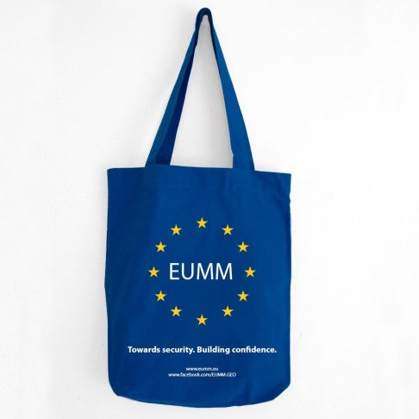
11 | Volley balls  Material: leather.  Colour: white and blue with EUMM logos (EUMM blue background –with ‘EUMM’ in white and yellow stars).  Number of EUMM logos minimum six.  Every 20th ball should be accompanied by a suitable air-pump.  Estimated Quantity:200 | 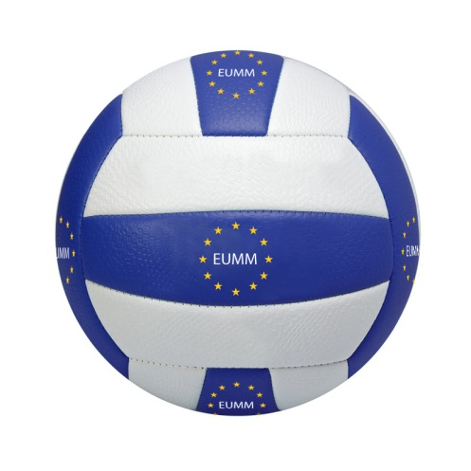
12 | T-Shirts  Cotton T-shirts with creative and innovative design, including at least some components from EUMM logo and slogan ‘Towards Security. Building Confidence.”  6 sizes:  100 small, 100 medium, 100 large, 100 X-large (regular fit) and 50 small, 100 medium, 50 large (lady fit)  Quality of Fabric:  Thickness of cotton: about 140- 180 g  Every T-shirt should be packed in a plastic transparent bag.  Estimated Quantity: 600
13 | Paper Folders  Paper folder with inside holder for paper, “wings” along vertical and horizontal edges to hold papers inside. Creative and innovative design, including at least some components from EUMM logo and slogan ‘Towards Security. Building Confidence.” Also website www.eumm.eu should be included to the design.  Four-colour printing.  Size: slightly larger than A4 (to put A4 papers inside)  Quality of the paper: laminated carton, min. 300 g  Estimated Quantity: 300 | 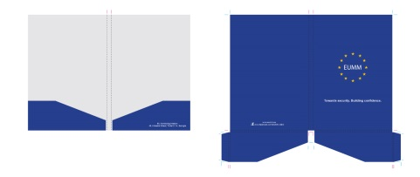
14 | Sport Drink Bottles  Refillable 0,5 liters blue plastic bottle (BPA Free, Made With PET, safe for drink ware, dishwasher safe material) with EUMM logo and slogan ‘Towards Security. Building Confidence.” printed in white.  Soft low density material for easy squeezing. Leak-free push-pull cap.  Estimated Quantity: 500 | 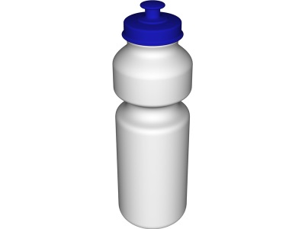
15 | Flash Drive, Memory sticks  Blue (with possible medal parts on silver colour) 4GB – with EUMM logo and EUMM website address (www.eumm.eu) printed in white. Each flash drive should be packed separately in brown (original carton) colour (see photo of item 5) factory box (max 4x8cm) with EUMM logo on it. At least 2 year factory warranty.  Estimated Quantity: 300
16 | Journal with pen  Blue journal/notebook with silver lacquered finish pen.  Pen: Silver/metal colour with free flow ink technology for consistent fluid lines, pocket clip, Engraved: www.eumm.eu  Journal: Approximately A5 size with a place for pen, 100-150 lined pages, artificial leather or padded textured hard cover.  Creative, stylish and minimalistic design, including at least some components from EUMM logo. Also slogan ‘Towards Security. Building Confidence.” and/or website address ww.eumm.eu should be included in design, for instance engraved/embossed in silver colour to the foot of back cover.  Every item is packed separately in blue or natural carton colour hard cover carton box which has EUMM logo pressed in it.  Estimated Quantity: 150 | 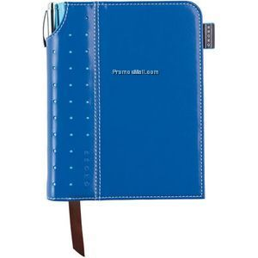

ANNEX IV : Budget breakdown (Model financial offer)
Contract on supply and delivery of visibility items with design to the EUMM, Georgia

Page No 1 [of ..]
Procurement reference: EUMM-14-3459

CONTRACT REFERENCE: EUMM-14-3459

NAME OF TENDERER: [……………………………]

A | B | C | D | E
Item number | Quantity | specifications offered (incl brand/model) | Unit costs with delivery DDP  EUR | total  EUR
1 | 1000
2 | 600
3 | 1000
4 | 1000
5 | 500
6 | 500
7 | 1000
8 | 500
9 | 300
10 | 300
11 | 200
12 | 600
13 | 300
14 | 500
15 | 300
16 | 150

Note:
The above amount must not be broken down further.
Such amount will be converted into Georgian Laris (GEL) if the bidder is a Georgia-based company. The conversion will be done using the InforEuro[1] exchange rate applicable on the tender closing date. Prices in the contract will also be expressed and paid in Georgian Laris (GEL) if the contract is awarded to a Georgia-based company.

ANNEX V:
LEGAL ENTITIES FORM & FINANCIAL IDENTIFICATION FORM

PLEASE SEE THE PDF FILE THAT IS ATTACHED TO THIS DOCUMENT

THOSE FORMS CAN ALSO BE DOWNLOADED FROM THE EUROPEAID WEBSITE USING THE FOLLOWING LINK:

http://ec.europa.eu/europeaid/prag/annexes.do?group=C

TENDER DOSSIER
EUMM-14-3459

ADMINISTRATIVE
COMPLIANCE GRID
PART C

EVALUATION GRID

PROVISIONAL/FINAL ACCEPTANCE CERTIFICATE

ADMINISTRATIVE COMPLIANCE GRID

Contract title : | Contract on supply and delivery visibility items with design to the EUMM, Georgia | Procurement reference: | EUMM-14-3459

Tender envelope number | Name of Tenderer | Is documentation complete?  (Y/N) | Is language as required?  (Y/N) | Is tender submission form complete?  (Y/N) | Is tenderer's declaration signed (by all consortium members if a consortium)? (Yes/No/ Not Applicable) | Other administrative requirements of the tender dossier?  (Yes/No/Not applicable) | Overall decision?  (Accept / Reject)
1
2
3
…

Chairperson's name
Chairperson's signature
Date

EVALUATION GRID
Contract title : | Contract on supply and delivery visibility items with design to the EUMM, Georgia | Procurement reference: | EUMM-14-3459

Tender envelope No | Name of Tenderer | Economic & financial capacity? (OK/a/b/…) | Professional capacity? (OK/a/b/…) | Technical capacity? (OK/a/b/…) | Compliance with technical specifications? (OK/a/b/…) | Ancillary services as required? (OK/a/b/…/NA) | Other technical requirements in tender dossier?  (Yes/No/Not applicable) | Technically compliant? Y/N) | Justification/  notes:
1
2
…

Evaluator's name & signature
Evaluator's name & signature
Evaluator's name & signature
Date

[PROVISIONAL / FINAL] ACCEPTANCE CERTIFICATE
Contract N°: EUMM-14-3459 – Title: Contract on supply and delivery visibility items with design to the EUMM, Georgia

INDICATE TYPE OF ACCEPTANCE
Contract/PO No: |  |  | Title:
PI number:
Contractor: |  |  |  |  | Contracting Authority:
Item | Qty | Description |  |  | (Installation) | (Spare Parts) | (Consumables) | (Manuals) | (Training) | Remarks
Item | Qty | Description | Delivery | Total Price
1 | […] | [……………………]
2 | […] | [……………………]
4 | […] | [……………………]
 |  |  |  | 0 | 0
[Provisional: All of the above mentioned items have been delivered, installed, tested and found compliant with the Technical Specifications of the supply Contract.]
[Final: The Supplier has remedied any defect or damage occurred during the warranty period, as specified in the Contract.]
The Contracting Authority
1. The Project Manager (on behalf of the Contracting Authority)
Name
Signature
Date when inspected and validated Stamp
OR
Date of delivery in case items were
not delivered to the MHQ warehouse
Goods delivery date to EUMM (actual delivery date of goods should be indicated rather than C-11 issue date):
2. For EUMM Warehouse (as applicable)
Name
Signature
Date when delivered to EUMM Stamp
3. The EUMM Assets Management Section (as applicable)
Name
Signature
Date when barcoded and/or recorded Stamp
The Contractor
0. The Project Manager (on behalf of the Contractor)
Name
Signature
Date Stamp

TENDER DOSSIER
EUMM-14-3459

PART D

TENDER FORM FOR A
SUPPLY CONTRACT

TENDER FORM FOR A SUPPLY CONTRACT
Procurement reference: EUMM-14-3459

Title of contract: Contract on supply and delivery visibility items with design to the EUMM, Georgia.
Tbilisi, .... January 2015
A:
European Union Monitoring Mission in Georgia (EUMM)
49 Krtsanisi Street
Tbilisi 0114 – Georgia
(“the Contracting Authority”),

One signed form must be supplied (for each lot, if the tender procedure is divided into lots), together with the number of copies specified in the Instruction to Tenderers. The form must include a signed declaration using the annexed format from each legal entity making the application. Any additional documentation (brochure, letter, etc.) sent with the form will not be taken into consideration. Applications being submitted by a consortium (i.e. either a permanent, legally-established grouping or a grouping which has been constituted informally for a specific tender procedure) must follow the instructions applicable to the consortium leader and its members. The attachments to this submission form (i.e. declarations, statements, proofs) may be in original or copy. If copies are submitted, the originals must be dispatched to the Contracting Authority upon request. For economical and ecological reasons, we strongly recommend that you submit your files on paper-based materials (no plastic folder or divider). We also suggest you use double-sided print-outs as much as possible.
An economic operator may, where appropriate and for a particular contract, rely on the capacities of other entities, regardless of the legal nature of the links which it has with them. It must in that case prove to the contracting authority that it will have at its disposal the resources necessary for performance of the contract, for example by producing an undertaking on the part of those entities to place those resources at its disposal. Such entities, for instance the parent company of the economic operator, must respect the same rules of eligibility and notably that of nationality, as the economic operator.

1 SUBMITTED BY
 | Name(s) of tenderer(s) | Nationality
Leader
Member
Etc …

2 CONTACT PERSON (for this tender)
Name
Address
Telephone
Fax
E-mail
3 ECONOMIC AND FINANCIAL CAPACITY
Please complete the following table of financial data based on your annual accounts and your latest projections. If annual accounts are not yet available for this year or last year, please provide your latest estimates, clearly identifying estimated figures in italics. Figures in all columns must be on the same basis to allow a direct, year-on-year comparison to be made (or, if the basis has changed, an explanation of the change must be provided as a footnote to the table). Any clarification or explanation which is judged necessary may also be provided.
Financial data | 2 years before last year  2011  EUR | Year before last year  2012  EUR | Last year  2013  EUR | Average  EUR | This year  2014  EUR
Annual turnover , excluding this contract
Current Assets
Current Liabilities
4 STAFF RESOURCES
Please provide the following personnel statistics for the current year and the two previous years.
Average manpower | Year before last |  | Last year |  | This year
 | Overall | Total for fields related to this contract | Overall | Total for fields related to this contract ¹¹ | Overall | Total for fields related to this contract ¹¹
Permanent staff
Other staff
Total
Permanent staff as a proportion of total staff (%) | % | % | % | % | % | %

5 FIELDS OF SPECIALISATION
Please use the table below to indicate the specialisms relevant to this contract of each legal entity making this tender, by using the names of these specialisms as the row headings and the name of the legal entity as the column headings. Show the relevant specialism(s) of each legal entity by placing a tick (✓) in the box corresponding to those specialisms in which the legal entity has significant experience. [Maximum 10 specialisms]
 | Leader | Member 2 | Member 3 | Etc …
Relevant specialism 1
Relevant specialism 2
Etc …
6 EXPERIENCE
Please complete a table using the format below to summarise the major relevant supplies carried out in the course of the past 3 years

by the legal entity or entities making this tender. The number of references to be provided must not exceed 15 for the entire tender
Ref # (maximum 15) | Project title |  | …
Name of legal entity | Country | Overall supply value (EUR) | Proportion supplied by legal entity (%) | No of staff provided | Name of client | Origin of funding | Dates | Name of members if any
… | … | … | … | … | … | … | … | …
Detailed description of supply |  |  |  |  |  | Related services provided
… |  |  |  |  |  | …

7 TENDERER’S DECLARATION(S)
As part of their tender, each legal entity identified under point 1 of this form, including every consortium member, must submit a signed declaration using this format. The declaration may be in original or in copy. If copies are submitted the originals must be dispatched to the Contracting Authority upon request.
In response to your letter of invitation to tender for the above contract,
we, the undersigned, hereby declare that:
1 We have examined and accept in full the content of the dossier for invitation to tender No EUMM-14-3459 of 23 December 2014. We hereby accept its provisions in their entirety, without reservation or restriction.
2 We offer to deliver, in accordance with the terms of the tender dossier and the conditions and time limits laid down, without reserve or restriction:
Lot 1: [description of supplies with indication of quantities and origin]
Etc.
3 The price of our tender excluding spare parts and consumables, if applicable [excluding the discounts described under point 4] is:
Lot 1: [……………………………………………..]
4 We will grant a discount of [%], or […………..] [in the event of our being awarded Lot … and Lot … ………].
5 This tender is valid for a period of 90 days from the final date for submission of tenders.
6 If our tender is accepted, we undertake to provide a performance guarantee as required by Article 11 of the Special Conditions.
7 Our firm/company [and our subcontractors] has/have the following nationality:
<……………………………………………………………………>
8 We are making this tender in our own right [as member in the consortium led by < name of the leader / ourselves > ]*. We confirm that we are not tendering for the same contract in any other form. [We confirm, as a member in the consortium, that all members are jointly and severally liable by law for the execution of the contract, that the lead member is authorised to bind, and receive instructions for and on behalf of, each member, that the execution of the contract, including payments, is the responsibility of the lead member, and that all members in the joint venture/consortium are bound to remain in the joint venture/consortium for the entire period of the contract’s execution].
9 We are not in any of the situations excluding us from participating in contracts which are listed in section 2.3.3 of the Practical Guide. In the event that our tender is successful, we undertake, if required, to provide the proof usual under the law of the country in which we are established that we do not fall into these exclusion situations. The date on the evidence or documents provided will be no earlier than 1 year before the date of submission of the tender and, in addition, we will provide a statement that our situation has not altered in the period which has elapsed since the evidence in question was drawn up.
We also undertake, if required, to provide evidence of financial and economic standing and technical and professional capacity according to the selection criteria for this call for tender specified in the contract notice, point 16. The documentary proofs required are listed in Section 2.4.11 of the Practical Guide.
We also understand that if we fail to provide the proof/evidence required, within 15 calendar days after receiving the notification of award, or if the information provided is proved false, the award may be considered null and void.
10 We agree to abide by the ethics clauses in Clause 23 of the instructions to tenderers and, in particular, have no conflict of interests or any equivalent relation in that respect with other tenderers or other parties in the tender procedure at the time of the submission of this application.
11 We will inform the Contracting Authority immediately if there is any change in the above circumstances at any stage during the implementation of the tasks. We also fully recognise and accept that any inaccurate or incomplete information deliberately provided in this application may result in our exclusion from this and other contracts funded by the EU/EDF.
12 We note that the Contracting Authority is not bound to proceed with this invitation to tender and that it reserves the right to award only part of the contract. It will incur no liability towards us should it do so.
13 We fully recognise and accept that we may be excluded from tender procedures and contracts, in accordance with Section 2.3.4 of the Practical Guide, for a maximum period of 5 years from the date on which the infringement is established and up to 10 years in the event of a repeat offence within the 5 years of the above-mentioned date. Furthermore, we acknowledge that, should we make false declarations or commit substantial errors, irregularities or fraud, we will also be subject to financial penalties representing 2 % to 10 % of the total estimated value of the contract being awarded. This rate may be increased to 4 % to 20 % in the event of a repeat offence within 5 years of the first infringement.
14 We are aware that, for the purposes of safeguarding the financial interests of the Communities, our personal data may be transferred to internal audit services, to the European Court of Auditors, to the Financial Irregularities Panel or to the European Anti-Fraud Office.

Yours faithfully
Name and first name: <[…………………………………………………………………>
Duly authorised to sign this tender on behalf of:
<…………………………………………………………………………………… …>
Place and date: <…………………………………………………………….………….>]
Stamp of the firm/company:
This tender includes the following annexes:
[Numbered list of annexes with titles]

[* Delete as applicable]

If this declaration is being completed by a consortium member:
The following table contains our financial data as included in the consortium’s tender form. These data are based on our annual audited accounts and our latest projections. Estimated figures (i.e. those not included in annual audited accounts) are given in italics. Figures in all columns have been provided on the same basis to allow a direct, year-on-year comparison to be made <except as explained in the footnote to the table>.
Financial data | 2 years before last⁵  EUR | Year before last year  EUR | Last year  EUR | Average⁶  EUR | This year  EUR
Annual turnover ⁷, excluding this contract
Current Assets⁸
Current Liabilities⁹

The following table contains our personnel statistics as included in the consortium’s tender form:
Average manpower | Previous year |  | Last year |  | This year
 | Overall | Total for fields related to this contract ¹¹ | Overall | Total for fields related to this contract ¹¹ | Overall | Total for fields related to this contract ¹¹
Permanent staff ¹²
Other staff ¹³
Yours faithfully
Name and first name: <[…………………………………………………………………>
Duly authorised to sign this tender on behalf of:
<…………………………………………………………………………………… …>
Place and date: <…………………………………………………………….………….>]
Stamp of the firm/company:
This tender includes the following annexes:
[Numbered list of annexes with titles]

<DDP (Delivered Duty Paid)> — Incoterms 2010 International Chamber of Commerce http://www.iccwbo.org/products-and-services/trade-facilitation/incoterms-2010/the-incoterms-rules/ .
For international companies the currency of tender shall be the currency of the Contract. However, for Georgia-based companies the currency of contract shall be Georgian Lari (GEL) using the InforEuro exchange rate published on the InforEuro webpage: http://ec.europa.eu/budget/inforeuro/index.cfm?Language=en applicable on the tender closing date.
DDP (Delivered Duty Paid) - Incoterms 2010 International Chamber of Commerce http://www.iccwbo.org/incoterms/id3040/index.html
Where the contracting party is an individual.
Where applicable. For individuals, mention their ID card or passport or equivalent document - number
Except where the contracting party is not VAT registered.
<DDP (Delivered Duty Paid)> - Incoterms 2010 International Chamber of Commerce - http://www.iccwbo.org/incoterms/
For international companies the currency of Contract and payment is EUR. However, for Georgia-based companies the currency of contract shall be Georgian Lari (GEL) using the InforEuro exchange rate published on the InforEuro webpage: http://ec.europa.eu/budget/inforeuro/index.cfm?Language=en applicable on the tender closing date.
DDP (Delivered Duty Paid) - Incoterms 2010 International Chamber of Commerce - http://www.iccwbo.org/incoterms/
Graphics guide to the European emblem for all items with coloured logo: http://publications.europa.eu/code/en/en-5000100.htm. Colours of the EUMM logo, all items: blue background, yellow stars and ‘EUMM’ and text in white.
DDP (Delivered Duty Paid) - Incoterms 2010 International Chamber of Commerce - http://www.iccwbo.org/incoterms/
[1] http://ec.europa.eu/budget/inforeuro/index.cfm?Language=en
The selection criteria, in the previous section of this form, have to be met before the technical requirements are assessed.
Country in which the legal entity is registered.
add/delete additional lines for members as appropriate. Note that a subcontractor is not considered to be a member for the purposes of this tender procedure. Subsequently, the data of the subcontractor must not appear in the data related to the economic, financial and professional capacity. If this tender is being submitted by an individual tenderer, the name of the tenderer should be entered as ‘leader’ (and all other lines should be deleted).
Natural persons have to prove their capacity in accordance with the selection criteria and by the appropriate means.
If this application is being submitted by a consortium, the data in the table above must be the sum of the data in the corresponding tables in the declarations provided by the consortium members — see point 7 of this tender form for a supply contract..
Last year=last accounting year for entity.
Amounts entered in the ‘Average’ column must be the mathematical average of the amounts entered in the three preceding columns of the same row.
The gross inflow of economic benefits (cash, receivables, other assets) arising from the ordinary operating activities of the enterprise (such as sales of goods, sales of services, interest, royalties, and dividends) during the year.
A balance sheet account that represents the value of all assets that are reasonably expected to be converted into cash within one year in the normal course of business. Current assets include cash, accounts receivable, inventory, marketable securities, prepaid expenses and other liquid assets that can be readily converted to cash.
A company's debts or obligations that are due within one year. Current liabilities appear on the company's balance sheet and include short term debt, accounts payable, accrued liabilities and other debts.
If this tender is being submitted by a consortium, the data in the table above must be the sum of the data in the corresponding tables in the declarations provided by the consortium members — see point 7 of this tender form for a supply contract.
Corresponding to the relevant specialisms identified in point 5 below.
Staff directly employed by the Tenderer on a permanent basis (i.e. under indefinite contracts).
Other staff not directly employed by the Tenderer on a permanent basis (i.e. under fixed-term contracts).
add / delete additional lines and/or rows as appropriate. If this tender is being submitted by an individual legal entity, the name of the legal entity should be entered as ‘Leader’ (and all other columns should be deleted).
In the case of framework contracts (without contractual value), only specific contracts corresponding to assignments implemented under such framework contracts will be considered.
Amounts actually paid, without the effect of inflation.

